

Renal Denervation Backgrounder
What is high blood pressure?
Blood pressure is the force that circulating blood exerts against the walls of the arteries – and hypertension, or high blood pressure, is when blood pressure is too high. High blood pressure is a significant global healthcare problem affecting over 1 billion people worldwide,¹ and is directly associated with increased risks of heart attacks, stroke, heart failure, kidney disease and death.2^{,3} For patients with high blood pressure that is difficult to control, medication and/or lifestyle changes can help to reduce blood pressure, but studies have shown that long term, many patients are often non-adherent to hypertension medication regimens.⁴

What is renal denervation, or the Symplicity blood pressure procedure?
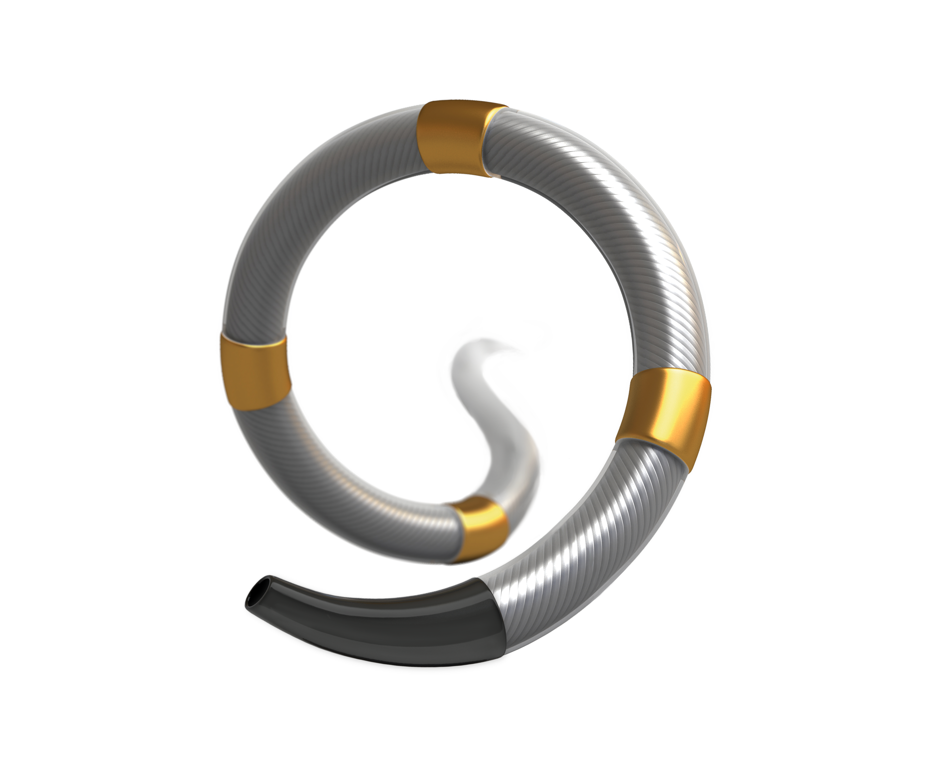
Recently approved by the U.S. Food and Drug Administration (FDA), the Symplicity Spyral™ renal denervation (RDN) system - also known as the Symplicity blood pressure procedure - is a minimally invasive procedure that targets nerves near the kidneys that can become overactive and cause high blood pressure. After sedation, the doctor inserts a very thin tube into the artery leading to the kidney. The doctor then administers energy to calm the excessive activity of the nerves connected to the kidney. The tube is removed, leaving no implant behind. The Symplicity blood pressure procedure is a proven way to help reduce blood pressure when medications and lifestyle changes aren’t enough.⁵⁻⁷

Where is the Medtronic Symplicity™ Renal Denervation System approved for use?
Approved for commercial use in more than 70 countries around the world – now including the United States - the Symplicity Spyral Renal Denervation System is currently limited to investigational use in Japan, and over 25,000 patients have been treated with this procedure.
# # #

¹ World Health Organization. Hypertension fact sheet. 13 September 2019. https://www.who.int/news-room/fact-sheets/detail/hypertension
²Whelton PK, Carey RM, Aronow WS, et al. 2017 ACC/AHA/AAPA/ABC/ACPM/AGS/APhA/ASH/ASPC/NMA/PCNA Guideline for the prevention, detection, evaluation, and management of high blood pressure in adults: a report of the American College of Cardiology/American Heart Association Task Force on clinical practice guidelines. Hypertension. 2018;71(6):e13−e115. doi: 10.1161/HYP.0000000000000065. Epub 2017 November 13.
³Mayo Clinic. High blood pressure dangers: Hypertension’s effects on your body. January 14, 2022.
⁴Osterberg L. and Blaschke T. (2005).Drug Therapy Adherence to Medication. The New England Journal of Medicine. 353:487-97.Copyright © 2005 Massachusetts Medical Society.
⁵Kandzari DE, Böhm M, Mahfoud F, et al. Effect of renal denervation on blood pressure in the presence of antihypertensive drugs: 6-month efficacy and safety results from the SPYRAL HTN-ON MED proof-of-concept randomised trial. The Lancet. 2018 Jun 9;391(10137):2346-2355.2.
⁶Böhm M, Kario K, Kandzari DE, et al. Efficacy of catheter-based renal denervation in the absence of antihypertensive medications (SPYRAL HTN-OFF MED Pivotal): a multicentre, randomized, sham-controlled trial. The Lancet 2020; Published online March 29, 2020. DOI: 10.1016/S0140-6736(20)30554-7.3.
⁷Townsend RR, Mahfoud F, Kandzari DE, et al. Catheter-based renal denervation in patients with uncontrolled hypertension in the absence of antihypertensive medications (SPYRAL HTN-OFF MED): a randomised, sham-controlled, proof-of-concept trial. The Lancet. 2017;390:2160–2170.

