[Hospital / Practice Name] in [STATE/CITY/REGION] is Providing Precise and Accurate Patient Customized Cranial Procedures

What custom cranial procedure is being offered? Stealth Autoguide™ is a cranial robotic positioning and guidance system that is engineered to provide precise positioning and guidance for cranial procedures. The platform can be used for neurological conditions requiring surgical procedures including biopsy, stereoelectroencephalography (sEEG), and laser tissue ablation.

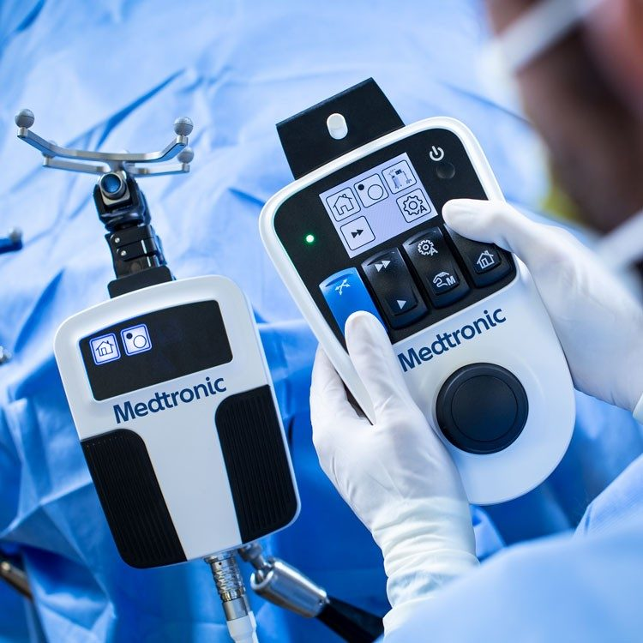
How does Stealth Autoguide™ work? The system accurately aligns to surgical plans for cranial procedures providing continuous real-time visualization, feedback, and robotically assisted movement that allows surgeons to align to surgical plans quickly and accurately for precision cranial procedures to improve surgical outcomes.

What are some other advantages of the Stealth Autoguide™? Surgeons are able to offer patients confidence that they have options to address their surgical needs with integration of cutting-edge instruments and implants to adapt to multiple surgical applications for a patient's specific case. When surgeons use Stealth Autoguide™, they can tailor treatments to each patient's individual needs by customizing the surgical procedure to match the patient’s anatomy. Through the increased precision and minimally invasive technique, patients could have shorter hospital stays. With a minimally invasive technique, surgeries require smaller incision and therefore are likely to have less blood loss. And through a 3D visualization of patient’s anatomy, there is enhanced surgical predictability with pre-operative and intra-operative planning

For more information about Stealth Autoguide™, please visit: https://www.medtronic.com/us-en/healthcare-professionals/products/neurological/cranial-robotics/stealth-autoguide.html

