[Hospital / Practice Name] in [STATE/CITY/REGION] is Transforming Outcomes for Patients in Need of Spine and Cranial Surgery with an Innovative Intra Operative Medical Imaging System

What new imaging system is being offered? The O-arm™ Imaging System by Medtronic. It provides immediate visualization of the patient’s anatomy during surgery, enabling surgeons to make informed decisions while operating.

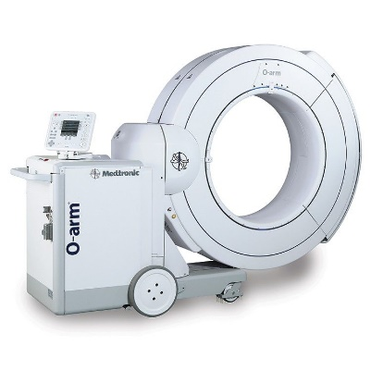
How does the O-arm™ Imaging System work? The O-arm™ Imaging Systems is a mobile x-ray device capable of taking 2D and 3D images for spine and cranial procedures. A 360-degree scan is taken, allowing the surgeon to have enhanced & precise visualization of a patient’s anatomy. This means that the surgeon can accurately confirm the intra operative position of the patient’s anatomy throughout the procedure while also confirming the placement of surgical hardware.

What are the benefits of using the O-arm™ Imaging System?

- Surgeons can confidently confirm implant placement without leaving the OR, thus reducing the potential for a revision surgery.
- The use of O-arm™ Imaging System in combination with StealthStation™ Navigation System improves the surgeons’ ability to perform MIS procedures, which may result in shorter hospital stays.

For more information about the innovative O-arm™ Imaging System, please visit: https://www.medtronic.com/us-en/healthcare-professionals/products/neurological/surgical-imaging-systems/o-arm.html

