Robotic Guidance System at [Hospital / Practice Name] in [STATE/CITY/REGION] Improves Predictability of Spinal Procedures

What is robotic guidance?
Spinal surgical robotic guidance systems give surgeons the ability to plan and perform spinal procedures with predictability and precision. The Mazor™ robotic guidance system provides advance planning and simulation features to enable the surgeon’s ability to select the surgical implant and placement in the body for procedures tailored to each patient.

How does the Mazor™ Robotic Guidance System work?
The Mazor™ robotic guidance system facilitates patient-specific treatment by enabling precise positioning of surgical instruments or spinal implants during spinal procedures, giving patients confidence in the predictability of their upcoming spinal surgery. Surgeons can perform the procedure created for a patient’s individual anatomy by tracking the position of instruments in relation to the body and identifying this position on 3D CT images used during the procedure. With the Mazor™ robotic guidance system, minimally invasive procedures are more predictable.
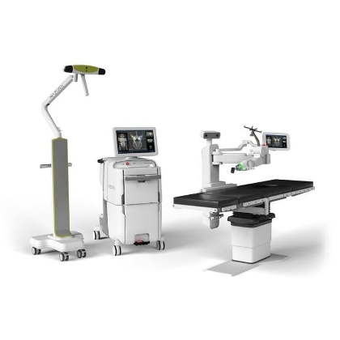
How else does Mazor™ robotic guidance system benefit patients?
The Mazor™ robotic guidance system helps surgeons improve planning before and during an operation. Using the system allows for potentially shorter hospital stays by enabling increased precision and minimally invasive techniques. Additionally, patients may experience smaller incisions and less blood loss during a surgery due to the minimally invasive technique. The system also offers patients confidence their surgeons have options to address their surgical needs with integration of drill systems and other navigational tools to adapt to multiple surgical applications for their specific case.

For more information about the Mazor™ robotic guidance system, please visit: https://www.medtronic.com/us-en/healthcare-professionals/products/spinal-orthopaedic/spine-robotics/mazor-x-stealth-edition.html

Mazor™ Robotic Guidance System
The Mazor X™ is indicated for precise positioning of surgical instruments or spinal implants during general spinal surgery. It may be used in either open or minimally invasive or percutaneous procedures.
Mazor X™ 3-D imaging capabilities provide a processing and conversion of 2-D fluoroscopic projections from standard C-Arms into volumetric 3-D image. It is intended to be used whenever the clinician and/or patient benefits from generated 3-D imaging of high contrast objects.
The Mazor X™ navigation tracks the position of instruments, during spinal surgery, in relation to the surgical anatomy and identifies this position on diagnostic or intraoperative images of a patient.
CONTRAINDICATIONS
Do not use the Mazor X™ system with any patient who has been diagnosed or is suspected of having Creutzfeldt-Jakob disease (CJD).

